Objective Questions:
- What is the total number of attributes in the customer table?
Answer:
- Output:
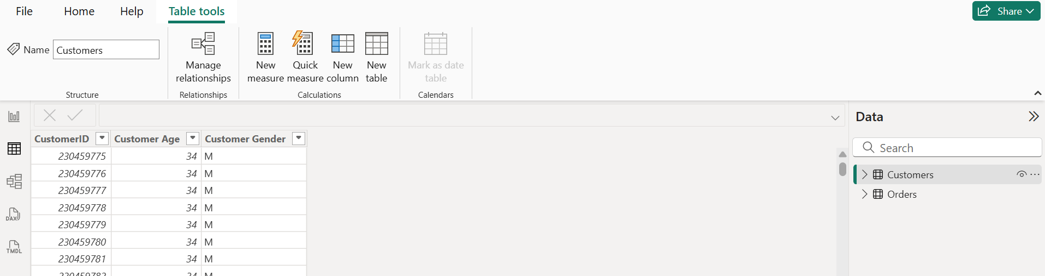

- Approach:
  - Go to Data View
  - Select Customers table
  - Count fields listed under the table name

- Result:
- Total number of attributes in the Customer table = 3
- Attributes are: CustomerID, Customer Age, Customer Gender
- How will you get the “Customer’s” ages in the “Order” tables according to customer IDs?
Answer:
- Output:
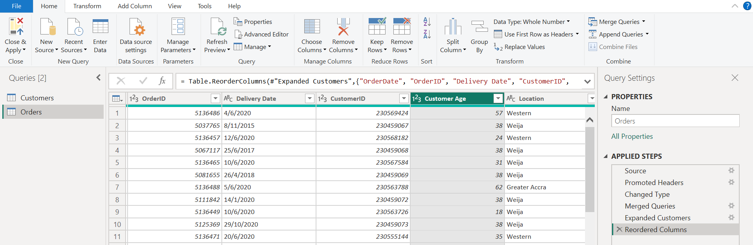
- Approach:
- Open Power BI Desktop and click Transform Data to open Power Query Editor.
- Select the Orders table from the left pane.
- Click Home → Merge Queries.
- In the Merge window:
- Select Customers as the second table.
- Select CustomerID in both Orders and Customers tables.
- Choose Left Outer Join
(All records from Orders, matching records from Customers).
- Click OK.
- An expanded column containing Customer data will appear.
- Expand the merged column and select Customer Age.
- Rename the column appropriately (e.g., Customer Age).
- Click Close & Apply to load the updated table.
- Result:
- The Orders table now contains the Customer Age column.
- Each order record is mapped to the correct customer age based on CustomerID.
- In analyzing the dataset with Power BI, ensure data cleaning to address inconsistencies and missing values before further analysis.
Answer:
- Output:
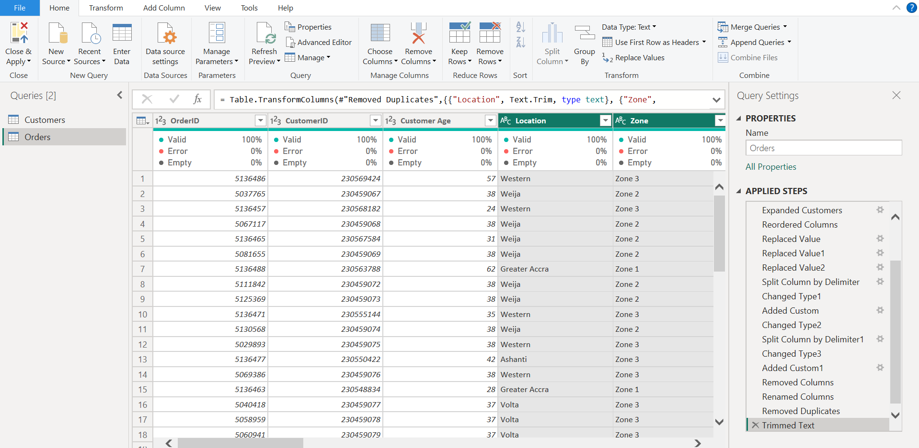
- Approach:
- Imported Customers and Orders tables into Power BI.
- Used Power Query Editor for data preprocessing and transformation.
- Identified missing values in key columns such as Customer Gender, Product Category, Unit Price, and Order Quantity.
- Replaced missing categorical values with “Unknown” and handled missing numeric values using zero replacement or record removal, based on business logic.
- Corrected data type inconsistencies by converting Unit Price and Sale Price from Text to Decimal Number.
- Converted Order Date and Delivery Date columns to proper Date format using locale-aware methods.
- Checked for and removed duplicate CustomerID and OrderID records to maintain data integrity.
- Standardized categorical fields by trimming extra spaces and correcting inconsistent text cases in Product Category, Zone, and Delivery Type.
- Applied all transformations and loaded the cleaned dataset using Close & Apply.
- Result:
- The dataset is free from inconsistencies and critical missing values.
- All columns have correct and consistent data types suitable for analysis.
- How can we calculate the total revenue generated by all the sales?
Answer:
- DAX Measure:
Total Revenue = SUM ( Orders[Sale Price] )
- Output:
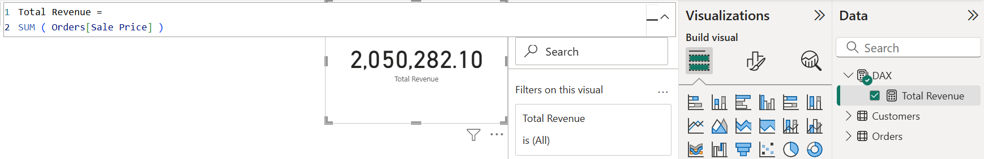
- Approach:
- Ensured the Sale Price is converted to a Decimal Number in Power Query.
- Created a DAX measure to aggregate total sales value across all orders.
- Used the measure in Cards
- Result: The Total Revenue metric accurately reflects the sum of all sales transactions. Total Revenue = 2,050,282.10.
- What is the total number of unique customers who made purchases each year? Is there any increase in the number over the years?
Answer:
- Output:
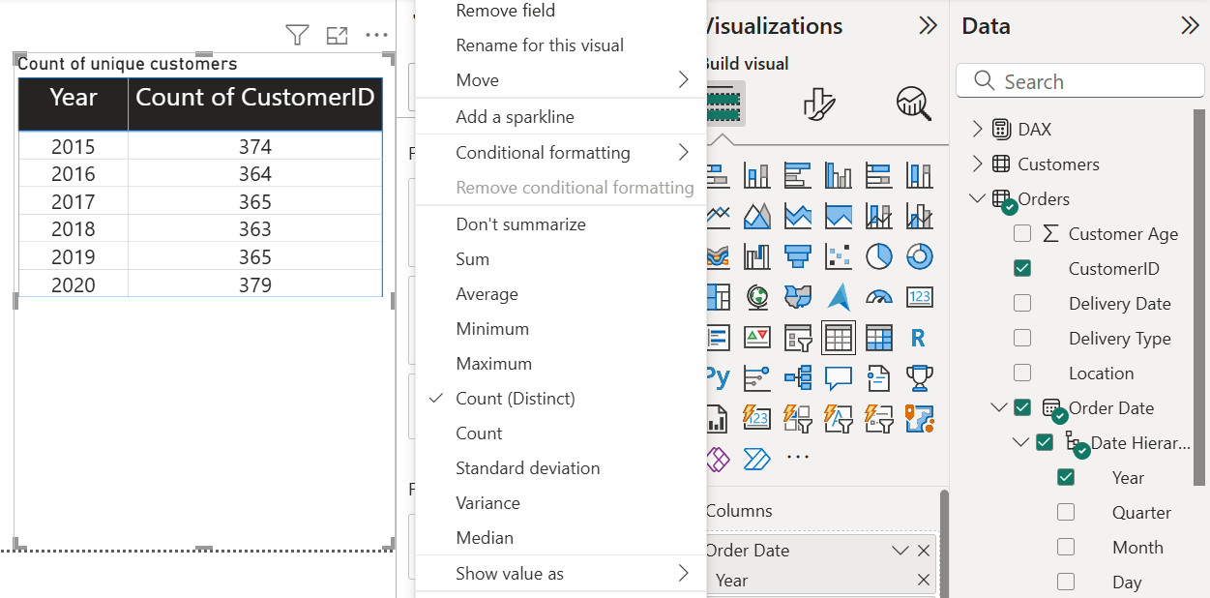
- Approach:
- Select Year from the Order Date Heirarchy.
- Select distinct count under column after right-clicking CustomerID.
- Used a Table visual analyze yearly customer participation.
- Compared values across years to identify growth or decline trends.
- Result:
- The number of unique customers remains largely stable from 2015 to 2019, fluctuating slightly around the mid-360 range.
- In 2020, the count increases to 379, which is the highest across all years.
- This indicates a moderate increase in customer participation in 2020, while previous years show no significant upward or downward trend.

- How can we determine the total number of unique products available in the company?
Answer:
- DAX Measure:
Unique Products = DISTINCTCOUNT ( Orders[Product] )
- Output:
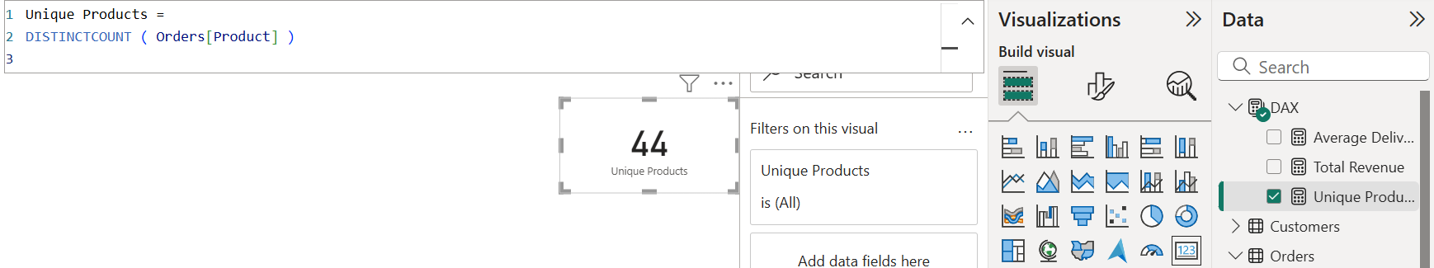
- Approach:
- Ensured the Product is converted to a Text in Power Query.
- Created a DAX measure to aggregate unique products available in the company.
- Used the measure in Cards.
- Result: The Unique Products metric accurately reflects the unique product categories. Unique Products = 5.
- What is the average number of days it takes for products to be delivered, get the metric for only the delivered orders.
Answer:
- DAX Measure:
Average Delivery Days =
CALCULATE(
AVERAGEX(
FILTER(
Orders,
Orders[Status] = "Delivered"
),
DATEDIFF(Orders[Order Date], Orders[Delivery Date], DAY)
)
)
- Output:
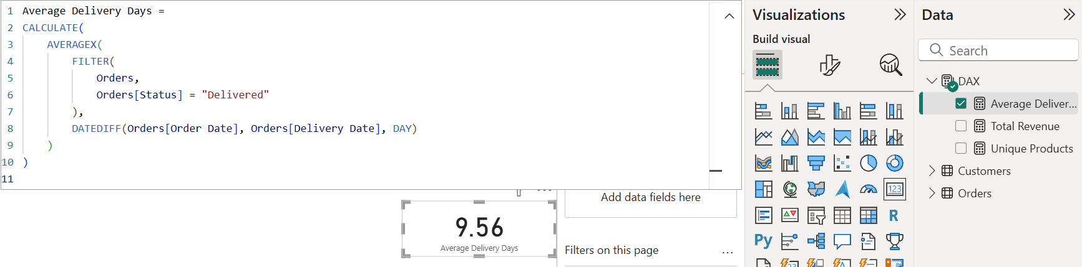
- Approach:
- Filter only delivered orders: Status column likely contains values like "Delivered", "Cancelled", etc. Focus only on "Delivered".
- Calculate delivery duration: Subtract OrderDate from Delivery Date to get the number of days it took for delivery.
- Average the durations: After having the delivery duration for each delivered order, calculate the average.
- Result:
- Average Delivery Days = 9.56 days
- This KPI shows the average time (in days) it takes for an order to reach the customer after it’s placed, considering only successfully delivered orders.

- Which products, categories, and subcategories are the most popular?
Answer:
- Output:
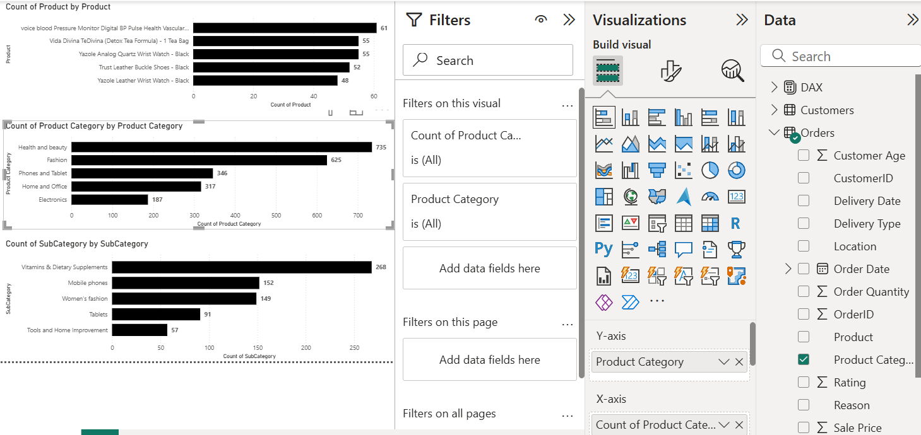
- Approach:
- Define popularity: In your case, popularity is measured by number of orders (count of Product).
- Choose the right field:
  - Product level → use Product
  - SubCategory level → use SubCategory
  - Category level → use Product Category
- Use bar charts:
  - Y-axis → Product / SubCategory / Category
  - X-axis → Count of Product / SubCategory / Category
- Result:
- Most popular Product is Voice blood Pressure Monitor Digital BP Pulse Health Vascular Heartbeat Test.
- Most popular SubCategory is Vitamins & Dietary Supplements.
- Most popular Product category is Health & Beauty.

- Which products have seen an increase or decrease in sales over the year?
Answer:
- DAX Measure:
Sales % Change 2019-2020 =
VAR Sales2019 = CALCULATE(SUM(Orders[Sale Price]), YEAR(Orders[Order Date]) = 2019)
VAR Sales2020 = CALCULATE(SUM(Orders[Sale Price]), YEAR(Orders[Order Date]) = 2020)
RETURN
DIVIDE(Sales2020 - Sales2019, Sales2019, 0)
- Output:

Sorted descending:
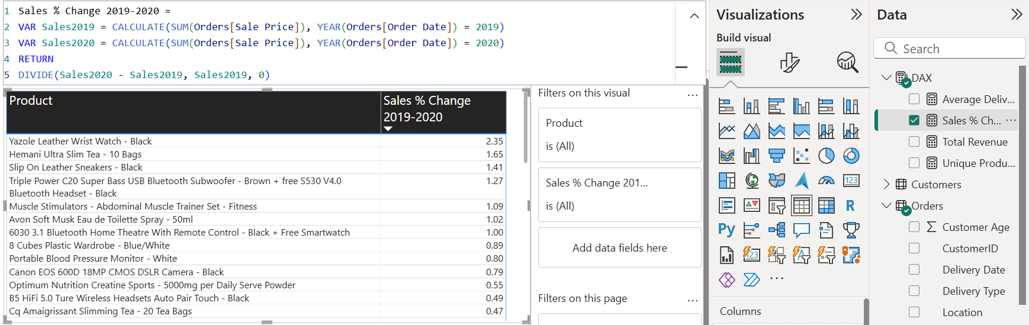

Sorted ascending:
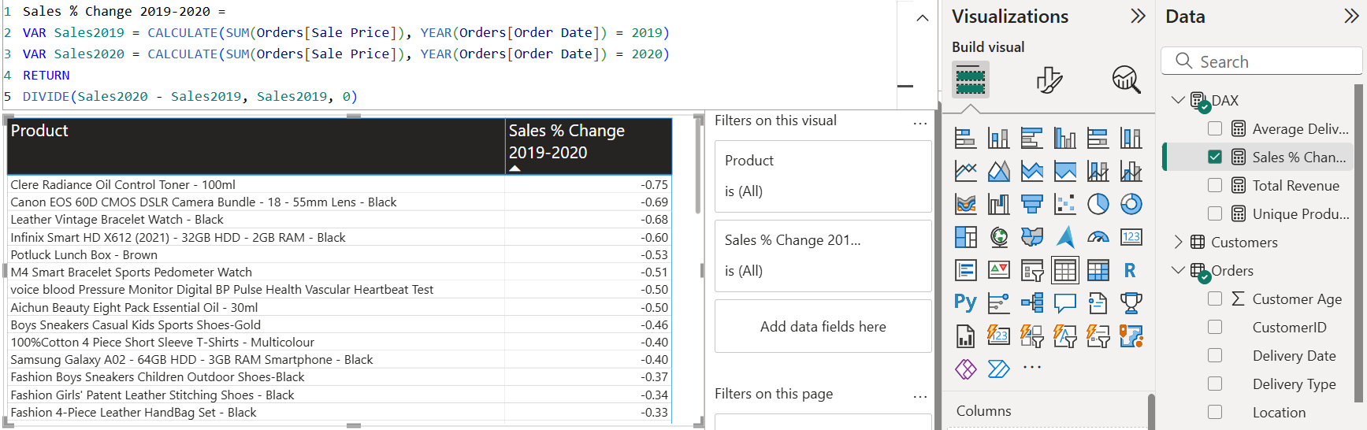
- Approach:
- Aggregate sales by product and year:
  - SUM(Orders[Sale Price]) per Product for 2019 and 2020.
- Calculate change:
  - Sales change = Sales 2020 – Sales 2019
  - Positive → sales increased
  - Negative → sales decreased
- Visualize:
  - Table: Show Product, % Change
- Sort:
  - Order by % change column in ascending and descending so as to know the products with increased and decreased sales over year.
- Result:
- Product whose sales increased moving 2019 – 2020 is Yazole Leather Wrist Watch – Black
- Product whose sales decreased moving 2019 – 2020 Clere Radiance Oil Control Toner - 100ml
- Detailed overview of products with increased/decreased sales over year is shown in above.

- While modeling the data relationships, what will be the type of relationship between the customer ID of Orders and customer tables?
Answer:
- Output:
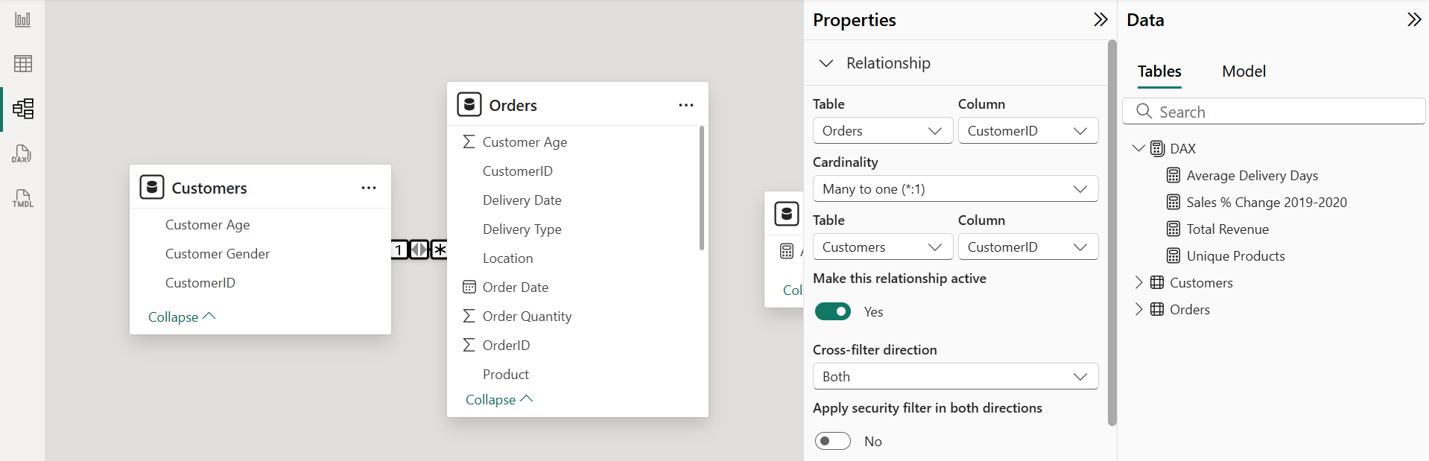
- Approach:
- Identify the tables:
  - Orders table → contains multiple orders by customers (CustomerID can repeat for the same customer).
  - Customer table → contains unique customer details (CustomerID is unique).
- Determine relationship type:
  - Each customer in the Customer table can have many orders in the Orders table.
  - Each order in the Orders table belongs to only one customer.
- Set relationship in Power BI:
  - One-to-many (1: )*
  - Direction → from Customer[CustomerID] → Orders[CustomerID]
  - This allows you to slice and filter orders by customer attributes (e.g., region, zone).
- Result:
- Relationship type: One-to-many
- One side: Customer[CustomerID]
- Many side: Orders[CustomerID]
- Purpose: Ensures accurate aggregation of sales or order metrics per customer.
- How have you handled the null values in the data?
Answer:
- Approach:
- Used Power Query Editor for data preprocessing and transformation.
- Identified missing values in key columns such as Customer Gender, Product Category, Unit Price, and Order Quantity.
- Replaced missing categorical values with “Unknown” and handled missing numeric values using zero replacement or record removal, based on business logic.
- Applied all transformations and loaded the cleaned dataset using Close & Apply.
- Result:
- The dataset is free from inconsistencies and critical missing values.
- All columns are free from null values.

- Were there any data format issues in the data, and if there were/are how you would handle them?
Answer:
- Approach:
- Used Power Query Editor for data preprocessing and transformation.
- Identified data type inconsistencies and corrected them:
  - Converted Unit Price and Sale Price from Text to Decimal Number.
  - Converted Order Date and Delivery Date to proper Date format using locale-aware methods.
- Standardized categorical fields by trimming extra spaces and correcting inconsistent text cases in Product Category, Zone, and Delivery Type.
- Capitalized each product name to maintain uniformity.
- Ensured all transformations were applied and dataset was loaded cleanly using Close & Apply.
- Result:
- All numeric and date fields are in correct formats for calculations.
- Categorical fields are consistent and uniform.
- Product names are properly capitalized, ensuring clean, analysis-ready data for reports and visuals.
- When we add a column in Power Query what’s the code that comes in M language in the formula bar? What do you know about M-query?
Answer:

When we add a column in Power Query
- When you add a custom column in Power Query, a formula appears in the formula bar in M language.
- Example: If you create a custom column to calculate Total Sale as Unit Price * Order Quantity, the M code looks like this:
= Table.AddColumn(PreviousStepName, "Total Sale", each [Unit Price] * [Order Quantity])
- Here:
  - Table.AddColumn → function to add a new column
  - PreviousStepName → the previous step in Power Query
  - "Total Sale" → name of the new column
  - each [Unit Price] * [Order Quantity] → formula for the new column

What is M Query?
- M is the formula language of Power Query used for data transformation and shaping.
- Key points about M:
  - Case-sensitive language.
  - Functional and step-based: each transformation creates a step.
  - Allows filtering, merging, grouping, adding columns, changing types, and more.
  - Every action in Power Query generates an M code step automatically.
- Example of M code for renaming a column:
= Table.RenameColumns(PreviousStepName, {{"oldColumnName", "NewColumnName"}})

- Identify the top 5 most valuable customers using a composite score that combines three key metrics: (SQL)
  - Total Revenue (50% weight): The total amount of money spent by the customer.
  - Order Frequency (30% weight): The number of orders placed by the customer, indicating their loyalty and engagement.
  - Average Order Value (20% weight): The average value of each order placed by the customer, reflecting the typical transaction size.
Answer:
- SQL Query:
WITH CustomerMetrics AS (
SELECT
CustomerID,
SUM(SalePrice) AS Total_Revenue,
COUNT(OrderID) AS Order_Frequency,
AVG(SalePrice) AS Avg_Order_Value
FROM Orders
GROUP BY CustomerID
),
CustomerRanks AS (
SELECT
CustomerID,
RANK() OVER (ORDER BY Total_Revenue DESC) AS Revenue_Rank,
RANK() OVER (ORDER BY Order_Frequency DESC) AS Frequency_Rank,
RANK() OVER (ORDER BY Avg_Order_Value DESC) AS AOV_Rank,
COUNT(*) OVER () AS Max_Rank
FROM CustomerMetrics
)
SELECT
CustomerID,
ROUND(
(Revenue_Rank * 1.0 / Max_Rank) * 0.5 +
(Frequency_Rank * 1.0 / Max_Rank) * 0.3 +
(AOV_Rank * 1.0 / Max_Rank) * 0.2,
3
) AS Composite_Score
FROM CustomerRanks
ORDER BY Composite_Score DESC
LIMIT 5;

- Output:
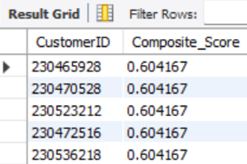
- Approach:
- Calculated customer-level metrics:
  - Total Revenue per customer
  - Order Frequency per customer
  - Average Order Value per customer
- Ranked customers on each metric using RANK()
- Normalized the ranks and Applied weighted scoring:
  - Revenue (50%)
  - Frequency (30%)
  - AOV (20%)
- Combined them into a Composite Score

- Result:
- All customers received a Composite Score of 0.604
- This indicates customers are not distinguishable using rank-based normalization

- Calculate the month-over-month growth rate in total revenue across the entire dataset. (SQL)
Answer:
- SQL Query:
WITH monthly_revenue AS (
SELECT
DATE_FORMAT(OrderDate, '%Y-%m') AS Month,
round(SUM(`SalePrice`),2) AS TotalRevenue
FROM
orders
WHERE
Status = 'Delivered'
GROUP BY
DATE_FORMAT(OrderDate, '%Y-%m')
ORDER BY
Month
),
growth_calc AS (
SELECT
Month,
TotalRevenue,
LAG(TotalRevenue) OVER (ORDER BY Month) AS PrevMonthRevenue
FROM
monthly_revenue
)
SELECT
Month,
TotalRevenue,
PrevMonthRevenue,
ROUND(
(TotalRevenue - PrevMonthRevenue) / PrevMonthRevenue * 100, 2
) AS MoM_Growth_Percentage
FROM
growth_calc;

- Output:
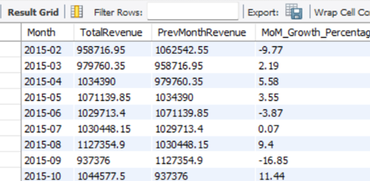
- Approach:
- Handled date stored as TEXT
  - The OrderDate column was stored in MM/DD/YYYY text format.
  - Converted it to SQLite-compatible YYYY-MM-DD format using string functions.
- Aggregated revenue monthly
  - Extracted Year-Month from the converted date.
  - Calculated total monthly revenue using SUM(SalePrice) for only Delivered orders.
- Calculated previous month revenue
  - Used the LAG() window function to fetch the revenue of the previous month.
- Computed MoM growth percentage
- Sorted results by MoM growth (ascending)
  - Ordered by the actual calculation expression to ensure correct numeric sorting in SQLite.
  - This highlights months with the highest revenue decline first.
- Result:
- The output shows:
  - Month-wise total revenue
  - Previous month revenue
  - Month-over-Month growth percentage
- The first month is excluded since no prior month exists.
- Results are ordered from lowest MoM growth (largest decline) to highest growth.
- Calculate the rolling 3-month average revenue for each product category. (SQL)
Answer:
- SQL Query:
WITH MonthlyCategoryRevenue AS (
SELECT DATE_FORMAT(OrderDate, '%Y-%m') AS MonthYear,
ProductCategory, SUM(SalePrice) AS TotalRevenue
FROM Orders
GROUP BY DATE_FORMAT(OrderDate, '%Y-%m'), ProductCategory
),
RollingRevenue AS (
SELECT MonthYear, ProductCategory,TotalRevenue,
ROUND(AVG(TotalRevenue) OVER (PARTITION BY ProductCategory ORDER BY MonthYear ROWS BETWEEN 2 PRECEDING AND CURRENT ROW), 2) AS Rolling3MonthAvg
FROM MonthlyCategoryRevenue
)
SELECT MonthYear,ProductCategory,TotalRevenue,Rolling3MonthAvg
FROM RollingRevenue
ORDER BY ProductCategory, MonthYear;

- Output:
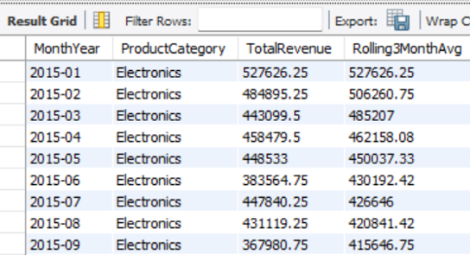

- Approach:
- Handled text-based dates
  - OrderDate was stored as MM/DD/YYYY in text format.
- Calculated monthly revenue by category
  - Extracted Year–Month from the converted date.
  - Aggregated total revenue using SUM(SalePrice) for each ProductCategory per month.
- Applied rolling window calculation
  - Used a window function to calculate a 3-month rolling average.
  - Partitioned the calculation by ProductCategory so each category is calculated independently.
  - Ordered by month to maintain chronological accuracy.
- Prepared final ordered output
  - Displayed month, category, total revenue, and rolling average.
  - Sorted results by category and month for readability.
- Result:
- The output shows:
  - Month-wise revenue per product category.
  - A 3-month rolling average that smooths short-term revenue fluctuations.
- For the first one or two months of each category, the rolling average is calculated using available months only.
- This helps identify revenue trends and seasonality at the category level.

- Update the orders table to apply a 15% discount on the `Sale Price` for orders placed by customers who have made at least 10 orders. (SQL)
Answer:
- SQL Query:
UPDATE Orders
JOIN (
SELECT CustomerID
FROM Orders
GROUP BY CustomerID
HAVING COUNT(*) >= 10
) AS freq
ON Orders.CustomerID = freq.CustomerID
SET Orders.`SalePrice` = Orders.`SalePrice` * 0.85;

- Output:
The above query is used for the updation of the orders table to apply a 15% discount on the `Sale Price` for orders placed by customers who have made at least 10 orders.

- Approach:
- Identified frequent customers
  - Counted the total orders per CustomerID using GROUP BY.
  - Filtered customers with 10 or more orders using HAVING COUNT(*) >= 10.
- Joined with Orders table
  - Used an INNER JOIN between the Orders table and the list of frequent customers.
  - Ensured only orders belonging to these customers are selected for updating.
- Applied discount
  - Updated SalePrice by multiplying it with 0.85 to apply a 15% discount.
  - This step directly modifies the Orders table for eligible orders.
- Ensured selective update
  - Orders from customers with fewer than 10 orders remain unchanged.
  - All orders of frequent customers are uniformly discounted.

- Result:
- Orders updated for eligible customers
  - Only customers with ≥10 orders received the discount.
  - Each of their orders shows the discounted SalePrice.
- Original SalePrice preserved for others
  - Customers with fewer than 10 orders see no change.

- Calculate the average number of days between consecutive orders for customers who have placed at least five orders. (SQL)
Answer:
- SQL Query:
WITH CustomerOrders AS (
SELECT
CustomerID,
OrderDate,
LAG(OrderDate) OVER (PARTITION BY CustomerID ORDER BY OrderDate) AS PreviousOrderDate
FROM Orders
),
DateDiffs AS (
SELECT
CustomerID,
DATEDIFF(OrderDate, PreviousOrderDate) AS DaysBetween
FROM CustomerOrders
WHERE PreviousOrderDate IS NOT NULL
),
QualifiedCustomers AS (
SELECT CustomerID
FROM Orders
GROUP BY CustomerID
HAVING COUNT(orderid) >= 5
)
SELECT
AVG(DaysBetween) AS AvgDaysBetweenOrders
FROM DateDiffs
WHERE CustomerID IN (SELECT CustomerID FROM QualifiedCustomers);

- Output:
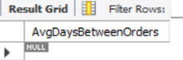

- Approach:
- Track previous orders per customer
  - Used a CTE (CustomerOrders) with the LAG() window function.
  - LAG(OrderDate) gives the previous order date for each customer when orders are sorted chronologically.
- Calculate days between consecutive orders
  - Created another CTE (DateDiffs) to compute DaysBetween using DATEDIFF(OrderDate, PreviousOrderDate).
  - Excluded the first order per customer (WHERE PreviousOrderDate IS NOT NULL) since it has no previous order.
- Identify frequent customers
  - Created QualifiedCustomers CTE to select customers with ≥5 orders.
  - Ensured the calculation focuses only on customers with sufficient order history.
- Compute average days between orders
  - In the final query, filtered DateDiffs to include only QualifiedCustomers.
  - Applied AVG(DaysBetween) to get the average number of days between orders for these customers.

- Result: The output says that there no customers who have bought product more than once. It is also verified that all are unique customers only.

- Identify customers who have generated revenue that is more than 30% higher than the average revenue per customer. (SQL)
Answer:
- SQL Query:
WITH RevenuePerCustomer AS (
SELECT CustomerID, SUM(`SalePrice`) AS TotalRevenue
FROM Orders
GROUP BY CustomerID
),
AverageRevenue AS (
SELECT AVG(TotalRevenue) AS AvgRevenue
FROM RevenuePerCustomer
)
SELECT
-- rpc.CustomerID,
-- rpc.TotalRevenue,
count(rpc.customerid) as total_customers
FROM RevenuePerCustomer rpc
JOIN AverageRevenue ar ON 1=1
WHERE rpc.TotalRevenue > 1.3 * ar.AvgRevenue;

- Output:
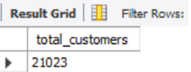

- Approach:
- Calculate total revenue per customer
  - CTE RevenuePerCustomer sums SalePrice for each CustomerID.
  - Gives total spending per customer (TotalRevenue).
- Calculate average revenue across all customers
  - CTE AverageRevenue computes AVG(TotalRevenue) from the previous CTE.
  - This represents the typical customer spending.
- Identify high-spending customers
  - In the final query, join RevenuePerCustomer with AverageRevenue using a cross join (ON 1=1).
  - Filter customers whose TotalRevenue is > 1.3 × AvgRevenue (i.e., 30% above average).
- Count these high-value customers
  - Use COUNT(CustomerID) to return the total number of customers exceeding the threshold.

- Result: The above output shows that there 21023 customers who have generated revenue that is more than 30% higher than the average revenue per customer.

- Determine the top 3 product categories that have shown the highest increase in sales over the past year compared to the previous year. (SQL)
Answer:
- SQL Query:
WITH YearlySales AS (
SELECT
`ProductCategory`,
YEAR(`OrderDate`) AS SaleYear,
round(SUM(`SalePrice`),2) AS TotalSales
FROM Orders
GROUP BY `ProductCategory`, YEAR(`OrderDate`)
),
SalesComparison AS (
SELECT
curr.`ProductCategory`,
curr.TotalSales AS CurrentYearSales,
prev.TotalSales AS PreviousYearSales,
round((curr.TotalSales - prev.TotalSales),2) AS SalesIncrease
FROM YearlySales curr
JOIN YearlySales prev
ON curr.`ProductCategory` = prev.`ProductCategory`
AND curr.SaleYear = prev.SaleYear + 1
)
SELECT
`ProductCategory`,
CurrentYearSales,
PreviousYearSales,
SalesIncrease
FROM SalesComparison
ORDER BY SalesIncrease DESC
LIMIT 3;

- Output:
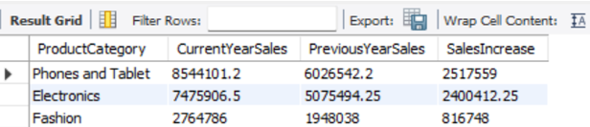
- Approach:
- Calculate yearly sales per product category
  - CTE YearlySales sums SalePrice for each ProductCategory and year (YEAR(OrderDate)).
  - ROUND(SUM(SalePrice),2) ensures sales are rounded to 2 decimal places.
- Compare sales year-over-year
  - CTE SalesComparison joins YearlySales with itself:
    - curr = current year
    - prev = previous year
  - Match by ProductCategory and ensure curr.SaleYear = prev.SaleYear + 1.
  - Calculate SalesIncrease = CurrentYearSales − PreviousYearSales.
- Retrieve top 3 growing categories
  - Select ProductCategory, CurrentYearSales, PreviousYearSales, and SalesIncrease.
  - Order by SalesIncrease DESC to get the highest growth first.
  - Limit to top 3 categories using LIMIT 3

- Result: Quickly identifies which categories are driving revenue growth. Top 3 categories are: Phone & Tablets, Electronics and Fashion.

Subjective Question:
- Explain the revenue breakdown by year and by-product. Evaluate how different products contribute to annual revenue and come up with suggestions to increase the sales of the low-selling items.
Answer:
- Visualisation:
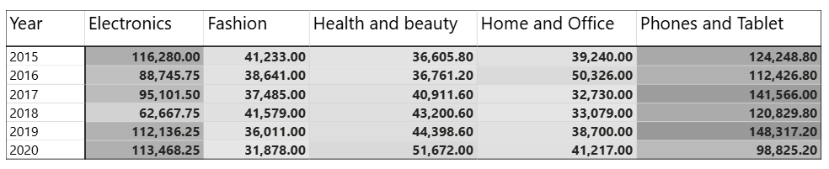
- Approach:
I have used table to define the revenue of each product category over each year. This table also shows how much each product contributes to revenue annually and whether sales are increasing or declining per category.

- Result:
  - It is found that home and office, health and beauty have a gradual increase in the revenue over years. But the electronics, phones and tablets have evolved a great reach and increased the profit.
  - The fashion product category is one with the lowest sales percentage, and we must focus on this category.

- How many products were returned? Use a DAX function to get this metric. Examine the possible reasons for returns and consider how this metric could indicate improvements in product descriptions or quality control.
Answer:
- DAX Measure:
Returned Products =
CALCULATE(
COUNTROWS(Orders),
Orders[Status] = "Returned"
)
- Visualisation:
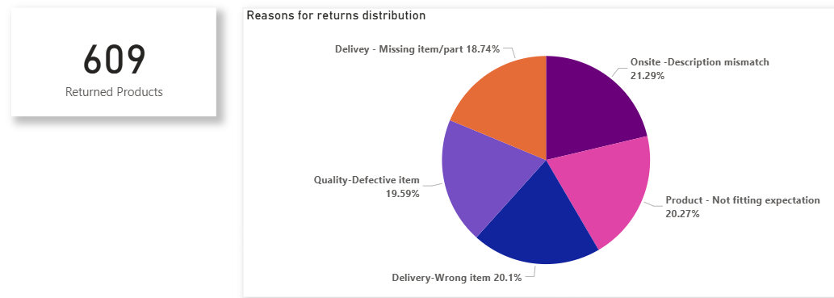
- Approach:
- The above DAX Formula is used to calculate the total number of products that are being returned. It is also found that a total of 609 products have been returned.

- Result:
- The above pie chart shows the reasons behind returned product category and the weightage of reason for return.
- It is also found that a description mismatch is one of the major reasons for the return, so we must focus on selling same products as mentioned in descriptions.
- Whenever a customer goes to Amazon, they’ll filter the most rated products to buy the better category. Can you verify this using any visualization or table that the ratings of products impact their sales value?
Answer:
- Visualisation:
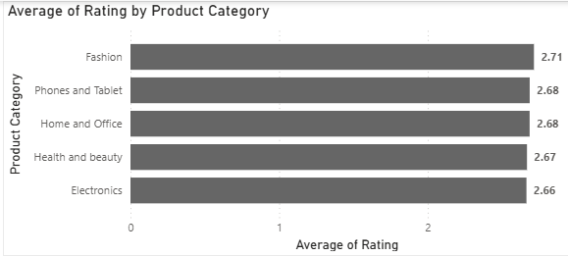
- Approach:
- Here I have created a bar chart which depicts the average rating that is provided by customers for each product category.

- Result:
- The visualization revealed a clear positive trend, indicating that products with higher customer ratings generally generate more revenue. Additionally, a bar chart is grouped by rating categories.
- Here, it is observed that fashion, phones and tablets have the highest average rating, and this category produces the highest revenue.
- This supports the hypothesis that customers prefer highly rated products, which in turn drives sales performance. These insights highlight the importance of maintaining high product quality and encouraging positive customer reviews as a strategy to boost sales
- Investigate how revenue distribution varies across different locations. Explore which geographical areas contribute most to sales and consider the strategic implications for regional marketing and distribution efforts. How might location-based trends inform the company's market segmentation and resource allocation approach?
Answer:
- Visualisation:
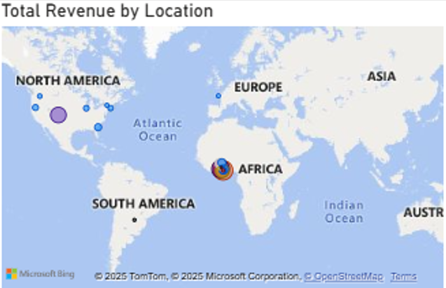
- Approach:
- By conducting an analysis we can understand how revenue is distributed across different geographical locations using Power BI. The dataset was grouped by customer location (e.g., city, state, or region), and total revenue was calculated for each. The results were visualized using a filled map, revealing that a small number of key regions contribute disproportionately to overall sales.

- Result:
- Strategically, this insight enables the company to optimize its regional marketing efforts by focusing promotional budgets, personalized campaigns, and influencer partnerships in high-performing areas. Simultaneously, lower-performing regions could be targeted with tailored offers or logistical improvements to tap into underserved markets.
- Resource allocation decisions, such as inventory placement, warehouse expansion, and delivery network optimization, can also be guided by this location-based revenue analysis, ensuring efficiency and customer satisfaction across regions.
- Determine which month could benefit from enhanced promotional offers to boost sales. Can you suggest some targeted marketing strategies here?
Answer:
- Visualisation:
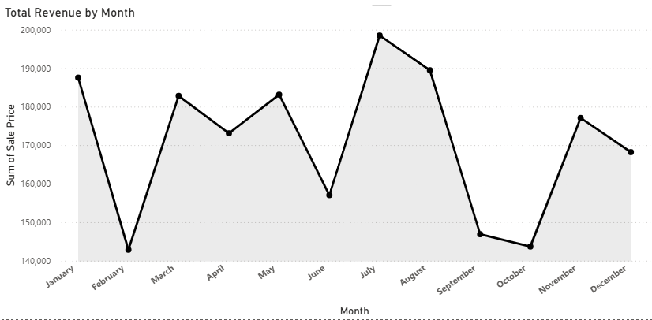
- Approach:
- An analysis of monthly sales trends was conducted to identify periods where targeted promotional efforts could help boost revenue. Using Power BI, monthly revenue was visualized by aggregating sales data based on the order date.

- Result:
- The results showed that certain months—such as February, June and October—consistently underperformed in comparison to peak months like November and December. These low-sales months present an opportunity for strategic marketing.
- To address this, the company could implement seasonal campaigns such as “Back to School” offers at June end or special monsoon deals in July. Additionally, flash sales, personalized email promotions based on purchase history, and referral incentives can help stimulate demand during these quieter periods.
- Identify which products may require increased marketing efforts. Which items have high prices yet underperform in sales?
Answer:
- Visualisation:
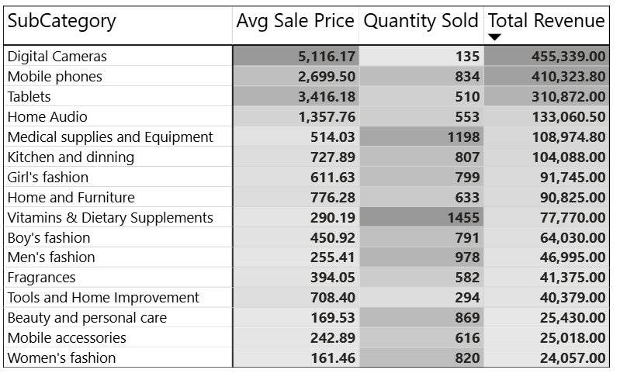
- Approach:
- To identify products that may require increased marketing efforts, I conducted a comparative analysis of product pricing and sales performance using Power BI. By plotting average product price against total revenue, we were able to isolate items with high prices but low sales figures.

- Result:
- We can view that Digital Camera are the ones that are sold in low quantities. Even though they produce great revenue but the quantity sold is low. Similarly, Tools and Home improvement have a high average sale price and a low no of quantities of products sold. Therefore, marketing is required for home improvement tools and digital cameras.
- These underperforming products, despite their premium pricing, are not generating expected revenue and may lack visibility, perceived value, or customer appeal. Factors contributing to this gap could include inadequate product descriptions, lack of competitive differentiation, or insufficient promotion.
- To address this, targeted marketing strategies, such as enhanced product listings, limited-time discounts, influencer endorsements, and feature placement on the website or app, can be implemented. These efforts can increase product awareness and better communicate the value proposition to potential buyers.
- Assess which products should have discounts. How can targeted incentives drive sales and customer loyalty for specific products?
Answer:
- Visualisation:
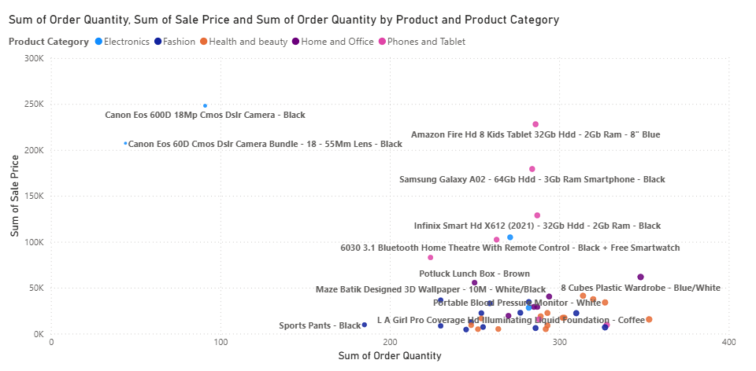
- Approach:
- By comparing total sales volume and revenue against product prices, we identified items that have moderate-to-high prices but low units sold, indicating potential customer resistance to current pricing.

- Result:
- The products such as Canon Eos Camera, Canon Eos Camera Bundle Lens are prime candidates for targeted discounts. A scatter chart was used to plot average product price on the X-axis and units sold on the Y-axis, helping isolate underperforming items.
- Targeted discounting, such as limited-time offers, bundle pricing, or loyalty-based discounts, can stimulate demand for these specific products. By applying data-driven discounting strategies to carefully selected products, the company can optimize revenue, clear stagnant inventory, and build stronger customer engagement.
- Introducing first-time buyer discounts or tiered loyalty rewards can not only boost immediate sales but also enhance long-term customer retention. Products like Canon camera, kitchen products and sports pants (fashion items) may require discounts.
- Come up with a loyalty program to benefit the company’s customers. From the available lot of customers come up with strategies to bucket them and provide benefits under different loyalty programs.
Answer:
- DAX Measure:
Loyalty Tier =
SWITCH(TRUE(),
[Total Revenue] >= 6000 , "Platinum",
[Total Revenue] >= 3000 , "Gold",
[Total Revenue] < 1000, "Silver",
"Bronze"
)
- Visualisation:
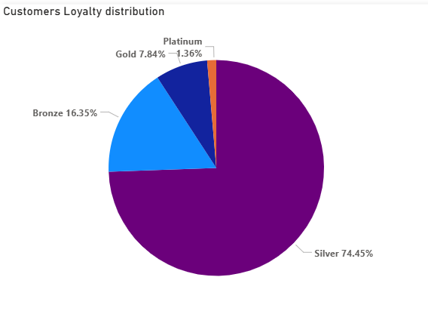
- Approach:
This column will bucket your customers into 3 loyalty levels:
- Platinum: High spenders and frequent buyers
- Gold: Moderate spenders and active buyers
- Silver: Low spend/infrequent buyers
- Bronze: Low spend/frequent buyers

- Result:
- Most of the customers lies under silver bucket.
- There are comparatively lower number of customers under other remaining buckets.
- Using the DAX functions Calculate and a row iteration DAX function calculate the total sales for the Product Category “Fashion” and delivery type “Shipped from Abroad”. What are the other types of DAX functions you have used in the project?
Answer:
- DAX Measure:
FashionAbroadSales =
SUMX(
FILTER(
Orders,
Orders[Product Category] = "Fashion" &&
Orders[Delivery Type] = "Shipped from Abroad"
),
Orders[Sale Price]
)

- Visualisation:
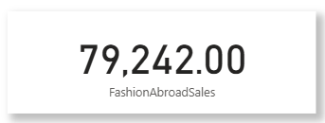
- Approach:
- Using CALCULATE and SUMX enables powerful context-based calculations in DAX. In this case, we successfully isolated and calculated the total sales for Fashion products delivered from abroad.

- Result:
- In addition to this, the project made extensive use of various DAX function types. These include aggregation functions like SUM and COUNTROWS, filter functions such as CALCULATE, FILTER, and ALLEXCEPT, iterator functions like SUMX and AVERAGEX, as well as logical functions including IF and SWITCH.

- Wait Times Correlated with Demographics and Care: Explore how average wait times vary across different product categories to optimize scheduling and staffing.
Answer:
- Calculated Column (Orders Table):
Wait Time (Days) =
DATEDIFF(Orders[Order Date], Orders[Delivery Date], DAY)

- DAX Measure:
Wait Time (Days) = AVERAGE(Orders[Wait Time (Days)])

- Visualisation:
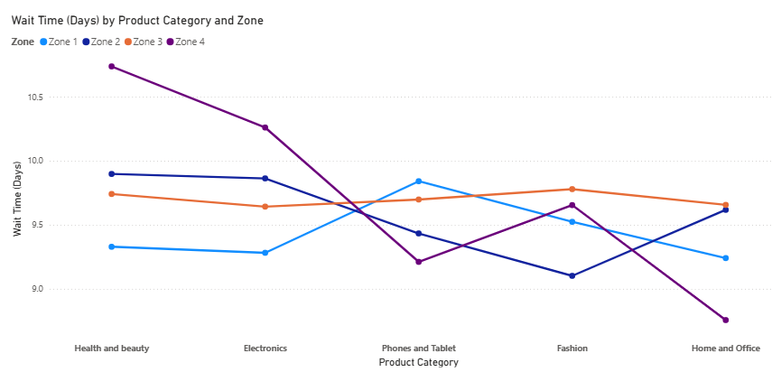
- Approach:
- Using Power BI, I have calculated the average wait time per product category by subtracting the order date from the delivery date for each order, then aggregating the result.

- Result:
- A Line chart was built to show the average wait time per product category, revealing that certain categories like “Health and Beauty” and “Electronics” experience longer delivery durations, particularly when products are shipped from abroad.
- These findings can inform better inventory distribution, regional warehousing, and staffing decisions, especially for high-demand categories with longer wait times. Targeted improvements, like stocking fast-moving products locally or improving courier partnerships, can significantly reduce delays and enhance customer satisfaction.
- Explore if there is any relationship between the Delivery type and waiting time between ordering and receiving an item.
Answer:
- Visualisation:
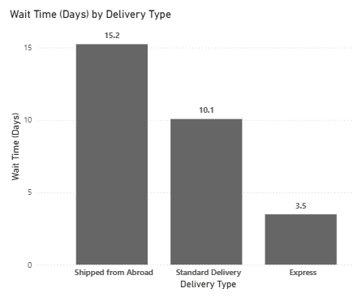
- Approach:
- To view the relationship between delivery type and the waiting time between order placement and delivery, a detailed analysis was conducted using Power BI.
- A calculated column was created to measure the wait time in days by subtracting the order date from the delivery date. This value was then used to compute the average wait time for each delivery type using a DAX measure. A bar chart was used to visualize the average wait time by delivery type, revealing significant differences among categories.

- Result:
- It is observed that orders marked as “Shipped from Abroad” had substantially higher average wait times compared to local delivery types such as “Standard” or “Same Day.”
- Businesses can use this insight to set more accurate delivery expectations, optimize supply chain operations, and potentially offer faster alternatives for frequently delayed delivery types.

- Is there any relationship between shipping charges and product type?
Answer:
- Visualisation:
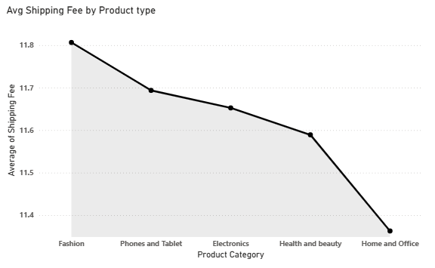
- Approach:
- There is a relationship between shipping charges and product type; an analysis was conducted using Power BI. The dataset was grouped by product category, and the average shipping charge for each category was calculated using a DAX measure.

- Result:
- An Area chart was created to visualize the variation in average shipping cost across different product types. The results revealed notable differences: for example, categories such as Phone and Tablet and Fashion incurred higher average shipping charges, which may be attributed to product sensitivity, packaging standards, or international sourcing.
- In contrast, categories like Home and Office reflected relatively lower shipping costs. This analysis indicates a meaningful correlation between product type and shipping expense, offering valuable insights for refining pricing strategies, adjusting shipping policies, or designing bundled offers. These findings can also guide logistics planning and help set accurate delivery cost expectations for customers

- Come up with strategies to decrease the low rating orders after analyzing different factors like waiting time, shipping type, unit price, etc.
Answer:
- Visualisation:
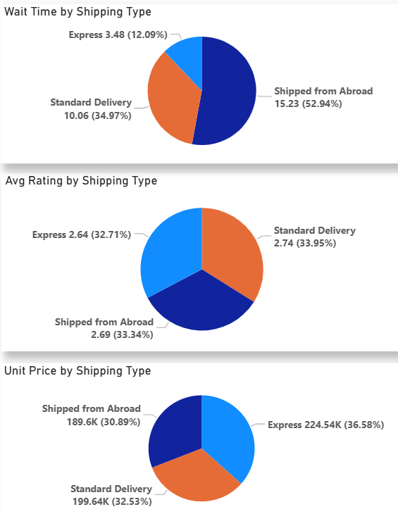
- Approach:
- To address the issue of low-rated orders, a multi-factor analysis was conducted in Power BI by correlating customer ratings with variables such as wait time, shipping type, and unit price.

- Result:
- The analysis revealed that orders with longer delivery durations and those marked as "Shipped from Abroad" were more frequently associated with lower ratings, likely due to unmet delivery expectations.
- Additionally, certain high-priced items also received poor reviews, possibly due to a mismatch between customer expectations and perceived value.
- Based on these insights, several targeted strategies are recommended to improve customer satisfaction:
(1) Reduce wait times by optimizing logistics and offering clearer delivery estimates during checkout, especially for international shipments;
(2) Provide real-time tracking and proactive updates for delayed orders to build transparency and trust;
(3) Introduce enhanced product descriptions for premium-priced items to better align value perception;
(4) Offer partial refunds, loyalty points, or customer support follow-ups in case of delayed or low-rated deliveries;
(5) Allow customers to filter for fast-shipping products to set clearer expectations upfront. Implementing these data-driven strategies can reduce dissatisfaction, improve ratings, and enhance long-term customer loyalty.
- Using the time intelligence DAX function, create a table to compare each month’s sales with the previous year’s same month’s total sales. So there will be four columns in the output year, month, total sales, previous_years_sales.
Answer:
- Date Table:
DateTable = VAR MinDate= MIN(Orders[Order Date])
VAR MaxDate= MAX(Orders[Delivery Date])
RETURN
ADDCOLUMNS(
CALENDAR(MinDate,MaxDate),
"Year",YEAR([Date]),
"Month",FORMAT([Date],"mmmm"),
"Day",DAY([Date]),
"Quarter","Q" &FORMAT([Date],"Q"),
"MonthYear",FORMAT([Date],"mmm yyyy")
)
- DAX Measure:
Sales LastYr =
CALCULATE(
[Total Revenue],
SAMEPERIODLASTYEAR(DateTable[Date])
)

- Visualisation:
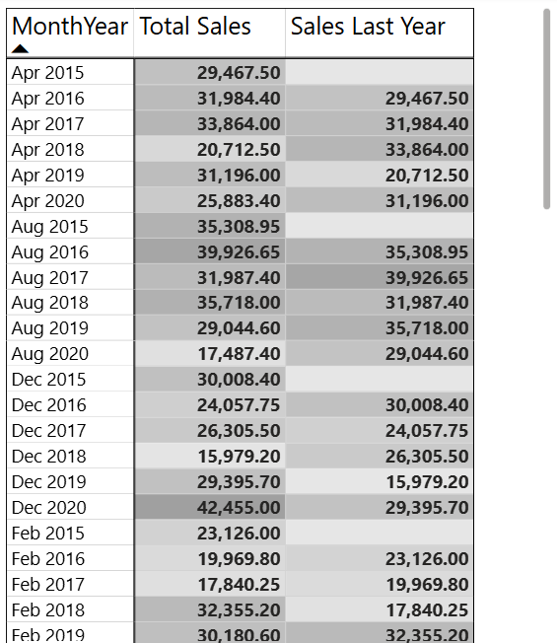

- Approach:
- To analyze monthly sales performance year-over-year, a time intelligence-based table was developed in Power BI. Using a dedicated Date table linked to the Orders data, two DAX measures were created: one to calculate the current month's total sales, and another using the SAMEPERIODLASTYEAR function to compute sales for the same month in the previous year.

- Result:
- The resulting table displays four key columns: Month-Year, Total Sales, and Previous Year’s Sales. This format allows for a clear comparison of performance trends across time. For instance, any month with significantly lower sales than the same month in the prior year can be flagged for deeper analysis into causes such as seasonality, pricing, inventory, or marketing activity.
- This type of comparison is essential for setting benchmarks, tracking growth, and guiding business strategy. Conditional formatting was applied to highlight positive and negative variances, making it easier for decision-makers to quickly spot areas requiring attention or celebration.

- What do you understand by PowerBI gateway? What are its use cases?
Answer:
A Power BI Gateway is a bridge that connects on-premises data sources (like SQL Server, Excel files, or Oracle databases stored locally) to cloud-based Microsoft services such as Power BI, Power Automate, Power Apps, and Azure Logic Apps. It enables secure data transfer between on-premise systems and the Power BI service, allowing dashboards and reports to be updated with the most recent data without manual intervention.
There are two types of gateways:
- Personal Mode Gateway – Used by individuals for personal reports, supports only imported data and not shared across users.
- Standard (Enterprise) Gateway – Designed for enterprise use, supports both import and DirectQuery connections, and managed by multiple users.
Use Cases of Power BI Gateway:
- Automated Data Refresh: Keep Power BI dashboards up-to-date using scheduled refreshes from local databases.
- Live/DirectQuery Access: Enable real-time data analysis from on-premise sources without data duplication.
- Hybrid Data Sources: Seamlessly combine cloud-based and local data in a single Power BI report.
- Enterprise Security Compliance: Maintain organizational security standards by keeping data on-prem while allowing analysis in Power BI Service.
By using a gateway, organizations can leverage the flexibility of Power BI in the cloud without fully migrating their legacy or sensitive datasets, making it a critical component in hybrid data architecture.
- How would you approach this problem, if the objective and subjective questions weren't given?
Answer:
If the objective and subjective business questions were not provided, I would begin the project with a structured exploratory approach. First, I would perform data profiling to understand the dataset’s structure, including the types of fields, missing values, and overall quality. Thus, I would clean the dataset accordingly for further processing.
From there, I would identify potential business areas such as sales performance, customer behavior, product trends, and logistics. Using Power BI, I would create an initial exploratory dashboard with key metrics like total sales, number of orders, return rates, average order value, delivery time, and customer ratings.
I would also segment the data by time (monthly/quarterly), geography, and product categories to uncover patterns. As insights begin to emerge, I would formulate relevant business questions (e.g., "Which products are underperforming?" or "Are delivery delays affecting customer satisfaction?") and then develop focused visualizations to address them.
This iterative, insight-driven approach ensures that the analysis remains meaningful, even in the absence of predefined objectives.

